|  |  |
| --- | --- |
|  |  |

**EXEDY (Singapore) Pte Ltd**

**Functional Specification Documentation**

Stock Aging Report

**Version No.: 1.0**

**Date: 21/11/2016**

**Table of Content**

1. Report Format 1

2. Report Requirement 2

# Report Format

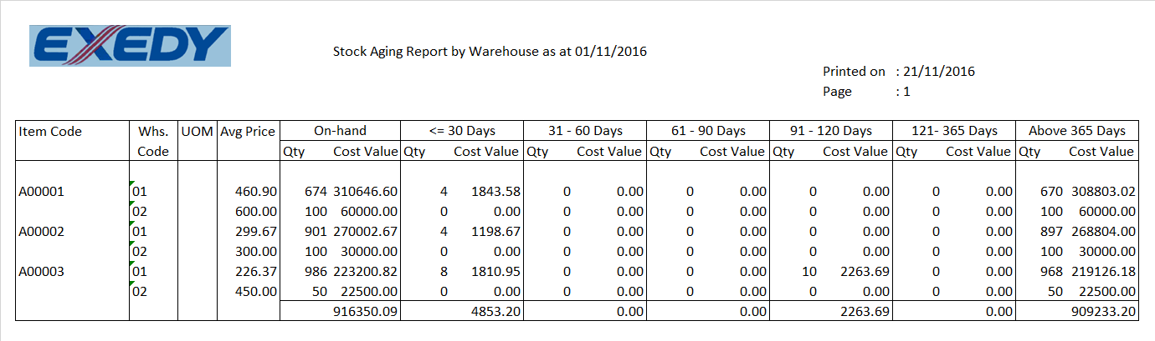

# Report Requirement

This report for accountant to adjust the stock.

**Report Type: Crystal Report and able to Export to Excel.**

**Parameter**: As of Date (Posting Date), Item Code Range, Warehouse Range (Optional)

As of selected date will be reflected in the report.

Breakdown by warehouse.

No need decimal point in quantity.

Put comma separator for both qty and amount.

|  |  |  |  |
| --- | --- | --- | --- |
| Column | Name | Data Get from Screen | Description |
|  | Item Code | Item Code |  |
|  | Warehouse | Warehouse |  |
|  | UOM | UOM |  |
|  | Avg. Price | OITW.AvgPrice |  |
|  | On-hand (Qty) | Current on-hand quantity |  |
|  | On-hand (Cost Value) | Current stock value |  |
|  | <=30days  (Qty) | Stock aging less than equal 30 days. |  |
|  | <=30days  (Cost Value) | Relevant ageing amount less then equal 30days. |  |
|  | 31-60days  (Qty) | Stock aging between 31 to 60 days. |  |
|  | 31-60days  (Cost Value) | Relevant ageing amount between 31 to 60days. |  |
|  | 61-90days  (Qty) | Stock aging between 61 to 90 days. |  |
|  | 61-90days  (Cost Value) | Relevant ageing amount between 61 to 90days. |  |
|  | 91-120days  (Qty) | Stock aging between 91 to 120 days. |  |
|  | 91-120days  (Cost Value) | Relevant ageing amount between 91 to 120days. |  |
|  | 121-365days  (Qty) | Stock aging between 121 to 365 days. |  |
|  | 120-365days  (Cost Value) | Relevant ageing amount between 121 to 365days. |  |
|  | Above 365days  (Qty) | Stock aging more than 365 days |  |
|  | Above 365days  (Cost Value) | Relevant ageing amount more than 365days. |  |

|  |  |  |  |  |
| --- | --- | --- | --- | --- |
| Accepted by | | | | |
| Project Manager, Customer | | | | |
| **Yes** | **No** |  | | |
| ***Name*** | ***Signature*** | ***Date*** |
| Project Manager, Abeo International Pte Ltd | | | | |
| **Yes** | **No** |  | | |
| ***Name*** | ***Signature*** | ***Date*** |